Dear Sir or Madam,

I am writing to urge you to support legal rights for the High Seas.

The Treaty for Biodiversity on the High Seas will establish a global framework to conserve and manage biodiversity of the high seas, which constitute almost two-thirds of the global ocean and covers nearly half of the planet. There have been decades of overfishing, destructive fishing and pollution and now extractive activities such as oil and gas exploitation and deep-sea mining are today expanding further and deeper. The added pressure caused by climate change and ocean acidification means that protecting marine ecosystems and building their resilience is more important than ever before in human history.
Currently more than 99% of the high seas are unprotected. Scientists advise that between 20-50% of the ocean should be protected as marine reserves to conserve and protect biodiversity and ocean health.

At the United Nations Ocean Conference June 2018, Earth Law Center launched the Rights of the Ocean Initiative, which has gained 71 signatories from 32 countries. (attached) The initiative highlights the growing recognition of the rights of nature by countries and organizations (United Nations and IUCN) worldwide, and experts calling for a holistic shift to ocean governance.

The initiative:

- URGES the United Nations to promote a shift to holistic and Earth-based management models;
- URGES the United Nations to incorporate the rights of the ocean into international treaty law to safeguard biodiversity, including the Marine Biodiversity Treaty for the High Seas and Beyond; and
- RECOMMENDS all governments and nongovernmental organizations, managers, practitioners and stakeholders adopt a holistic and rights-based management, including the development and management of marine protected areas using the ‘Earth Law Framework for Marine Protected Areas.’
There are multiple ways to incorporate rights of the ocean into the treaty. Some suggested text includes, but is not limited to:

As an Objective
- the conservation of marine biological diversity of areas beyond national jurisdiction, for the conservation of the ocean and entire Earth community.
- To first and foremost preserve the marine system in as far as possible its natural state and to retain the natural character of areas beyond national jurisdiction with significant and unique natural values.
- to conserve the ocean and prevent or eliminate any activity which may harm the ocean’s rights; in the case of conflict, ocean conservation will be the priority
As Guiding principles and approaches
- the instrument recognizes and protects the ocean’s inherent rights and intrinsic value.
- protected area management must place us within the capacity of natural laws.
- prevent declaring the ocean as a “resource,” and instead aim to define the ocean (the high seas) as a legal entity subject to basic rights
- governance must aim to conserve and restore the ocean as the highest objective for management.
- governance of areas beyond national jurisdiction must aim to achieve a ‘healthy ocean’ where healthy is informed by science and defined by the ocean’s own well-being and natural state, rather than defined by its utility to humans.
- a significant proportion of areas beyond national jurisdiction must be set aside to exist without human disturbance, fifty percent at least.
- we have a collective responsibility and right to respect and protect the ocean, and we are allowed to exercise that right.
- the ocean is a complex interconnection of systems and processes and the absence of concrete information should not prevent protective and restorative action
- the burden of proof shall be placed on those wishing to undertake the extractive or exploitative activity.

Binding Provisions

The Ocean is its own entity subject to basic rights. These basic rights include:

- To life: The right to maintain the integrity of living systems and natural processes that
sustain the ocean and Earth as a whole, and capacities and conditions for regeneration.
All species of the ocean, plants, animals and microorganisms, have the right to life. The
right to have critical and significant areas set aside for the continuation of cycles and
processes where no human activity may occur (no take zones). The ocean has a right to
life in perpetuity, and for humans to ensure that the pursuit of human well-being contributes to the wellbeing of the ocean now and into the future.
- To health and wellbeing: Where health is defined in terms of the ocean’s own
wellbeing and in relation to its natural state. The right to live free from torture or cruel
treatment by human beings and to exist in its natural state and habitat. The right to be
free from contamination, pollution (including noise and plastic) and toxic or radioactive
waste.
- To the diversity of life: The ocean has the right to biodiversity and to evolve. It has the
right to the differentiation and variety of beings that make up the ocean. It has the right to
not have its beings genetically altered or structurally modified in an artificial way,
including in any way that threatens their existence, functioning or future potential .
- To water: The right to water as a source of life. The right to preserve the functionality of
the water cycle, its existence in the quantity and quality needed to sustain living and
nonliving systems, and its protection from pollution for the reproduction of the life of the
ocean and all its components. This includes the right to maintain ocean temperature and
chemical composition (carbon dioxide proportions) at a level which does not threaten the
ocean’s integrity or vital and healthy functioning.
- To clean air: The right to preserve the quality and composition of air, and the
functionality of the carbon cycle, for sustaining living and nonliving systems and its
protection from pollution, for the reproduction of the life of the ocean and all its
components.
- To equilibrium: The right to maintenance or restoration of the interrelationship,
interdependence, complementarity and functionality of the components of the ocean in a
balanced way for the continuation of its vital cycles and processes. The ocean has a
right to live in harmony with humans and exhibit normal form and function.
- To restoration: The right to timely and full restoration of impacts by direct or indirect
human activities.
- To representation: The right to recognition everywhere before the law, during decision
making about activities that may impact the ocean and its rights, and before the
commencement of activities which may impact the ocean and its rights.

Conclusion:

With the ocean recognized as a legal entity, it is taken out of the realm of property. The High Seas, therefore, no longer belongs to one Nation, or all Nations, but instead is a living area belonging to itself, with representation of its interests that we must respect and manage responsibly and sustainably. The ocean, needs us to transform our governance systems, to recognize that nature has inherent rights to live, thrive and evolve, and to acknowledge that humans have a responsibility to respect and protect those rights. Now is not the time for business as usual.

Will you support the inclusion of the rights of the ocean at the upcoming treaty negotiations? Together we can ensure a healthy and thriving ocean now and into the future.

Sincerely,

Adoption of Holistic and Rights-based Ocean Governance
The undersigned organizations and our members and supporters worldwide:
NOTING that the ocean covers over seventy percent of our planet, generates over fifty percent of the oxygen, regulates climate, and provides food and jobs for millions of people.

ALSO NOTING that over-fishing, pollution and habitat destruction has led to a global decline in marine biodiversity of 49%, roughly half of what it was 50 years ago;

NOTING that the ocean is the “source of life,” and “marine biodiversity is vitally important for human well-being as it underpins a wide range of ecosystem services on which life depends;”
NOTING that continuing ocean degradation and associated expansion of management challenges together urge heightened regulatory and stewardship initiatives towards achieving ocean health;
FINDING that the lack of a coherent and shared vision of what a healthy ocean looks like, and what our associated relationship with it should be, is an underlying root cause of humanity's failure to implement effective measures to safeguard the health of the ocean.
FINDING that a shared vision of a healthy ocean must reflect the oceans inherent rights to health for its own sake, and must be grounded in values of connection, stewardship and respect for the ocean’s well-being, rather than primarily from the context of the ocean’s utility to humans;
ALSO FINDING that the governance of ocean resources should be guided by principles of sustainability, ecosystem health, precaution, and recognition of the interconnectedness between land and ocean;
RECALLING that the International Union for the Conservation of Nature (IUCN) committed to take action to implement nature’s inherent rights, including the pursuit of “protected area governance systems that achieve the effective and equitable governance of natural resources are recognized (as best practices/ pilot testing), supported and promoted, while respecting the rights of nature” to achieve SDG 14;

RECALLING that UN Resolution 71/232 (“Harmony with Nature,”) “[c]alls for holistic and integrated approaches to sustainable development, it its three dimensions, that will guide humanity to live in harmony with nature and lead efforts to restore the health and integrity of the Earth’s ecosystems;”

ALSO RECALLING that the experts’ summary report of the first virtual dialogue of the General Assembly on Harmony with Nature recommends that all parties
- “[d]evelop a new, integrate legal perspective and policy framework around rights of nature;”
- “[a]dopt a United Nations resolution endorsing the importance of exploring the potential of Earth Jurisprudence as a framework for developing international, national and local governance systems that will enable human communities to live in Harmony with Nature;” and
- “[w]ork to develop standards for implementation of the rights of Nature for all countries, for example, on the definition of the “health” of an ecosystem or species.”

ALSO RECALLING that the United Nations World Charter for Nature acknowledges that “mankind is a part of nature” and that “living in harmony with nature gives man the best opportunities” for living well. Noting that “every life form … warrant[s] respect regardless of its worth to man,” the charter declares, “Nature shall be respected and its essential processes shall not be impaired.” The Charter calls upon a moral code of conduct to guide human action in a way that treats other organisms with respect. Additionally, a primary function of the agreement is to recognize that man’s needs can only be met “by ensuring the proper functioning of natural systems.”

FINDING that experts call upon a holistic and rights-based approach to ocean governance:
- the United Nations Sustainable Development Knowledge Platform for Oceans and Seas states “[h]uman well-being cannot be achieved without the protection and conservation of the Earth’s ecosystem. To maintain the quality of life that the oceans have provided to humankind, while sustaining the integrity of their ecosystems, a change will be required in how humans view, manage and use oceans, seas and marine resources.”
- the IUCN’s 2017 Large Scale Marine Protected Areas Guidelines notes “[t]he key is for all players to commit to effective and equitable governance and management that seeks to conserve biodiversity in parallel with influencing, for the better, the economic, social and political drivers that affect ecosystem management, nature-based livelihoods, and the rights and responsibilities for nature (IUCN, 2012).” It further requires that human activities are managed holistically and the use of “a holistic management model that seeks to understand the relationship between nature, culture and the human dimension.”
- the National Oceanic and Atmospheric Association (NOAA) calls upon the recognition of ecological interconnectedness and complexity as crucial to managing marine ecosystems. NOA finds holism as essential to sustainable development. In multiple reports, NOAA noted that a holistic approach is distinct from current approaches,and to achieve the needed holism, we must reject and replace “many (but not all) of the processes upon which conventional management depends.”
- the International Earth system expert workshop on ocean stresses and impacts concluded “[h]uman interactions with the ocean must change with the rapid adoption of a holistic approach to sustainable management of all activities that impinge marine ecosystems. This has to be part of a wider re-evaluation of the core values of human society and its relationship to the world and the resources on which we rely.”
- the international Food and Agriculture Organization notes that marine protected areas must merge two converging paradigms —ecosystem management and fisheries management. Sustainable development can be achieved if the two “converge towards a more holistic approach that balances both human well-being and ecological well-being.”

RECOGNIZING that adopting the inherent rights of the ocean in law and policy will encourage a more holistic approach to ocean governance, the consideration of the impacts of our actions on both current and future generations of systems and people, and more protective and restorative activities, thus maintaining healthy and thriving ocean ecosystems.
OBSERVING that recognition of the inherent rights of the ocean include, but are not limited to, the right to life, the right to health, the right to be free of pollution and the right to continue its vital cycles.
AND NOTING that recognition of the inherent rights of the ocean will advance SDG Goal 14, including targets 14.1, 14.2, 14.2.1, 14.4, 14.5 and 14.C;
- URGES the United Nations to promote a shift to holistic and Earth-based management models;
- URGES the United Nations to incorporate the rights of the ocean into international treaty law to safeguard biodiversity, including the Marine Biodiversity Treaty for the High Seas and Beyond; and
- RECOMMENDS all governments and nongovernmental organizations, managers, practitioners and stakeholders adopt a holistic and rights-based management, including the development and management of marine protected areas using the ‘Earth Law Framework for Marine Protected Areas.’
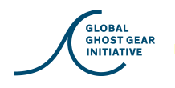
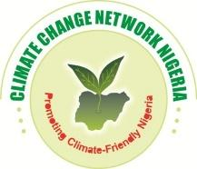
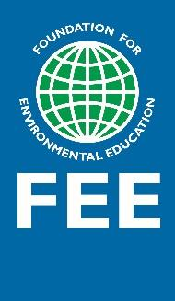
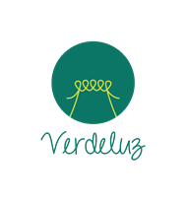
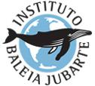
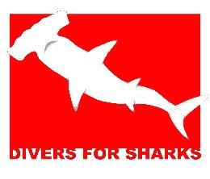
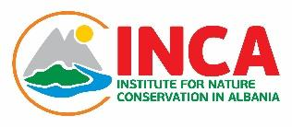
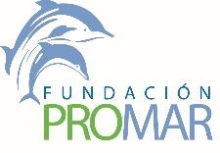
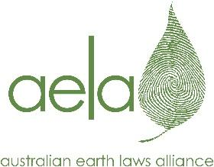
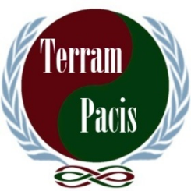
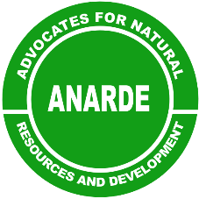
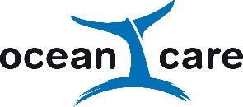
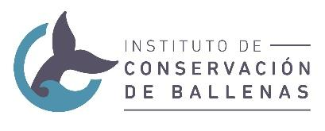
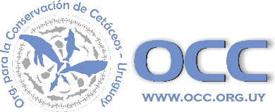
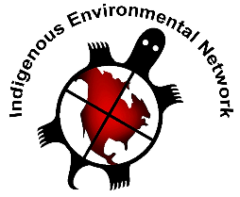
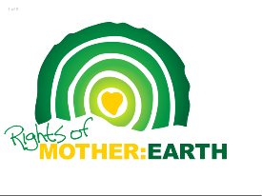
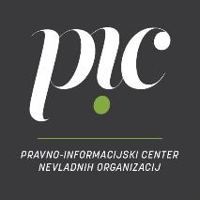
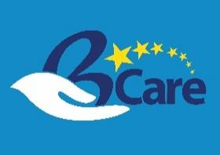
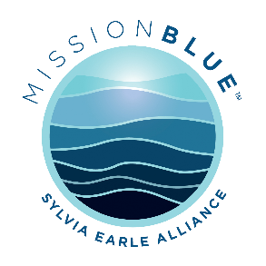
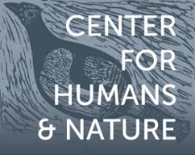
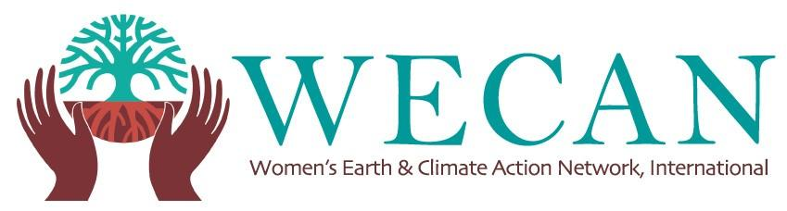
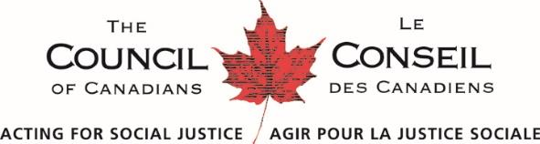
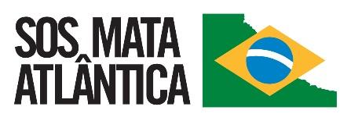
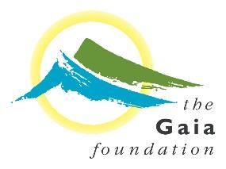
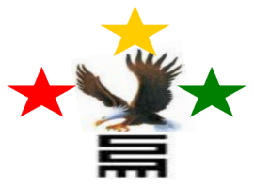
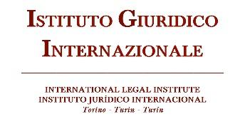
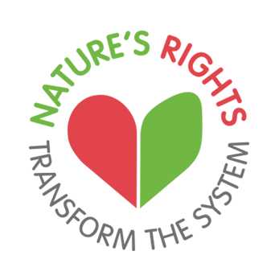
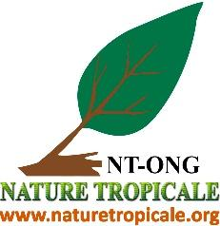
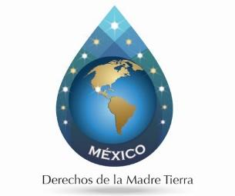
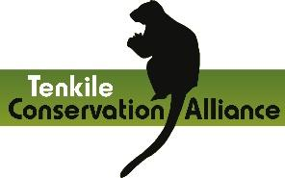
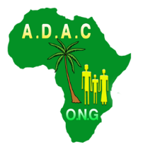
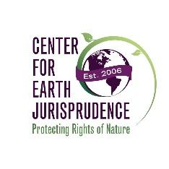
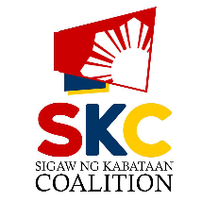
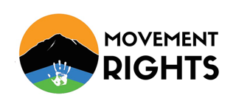
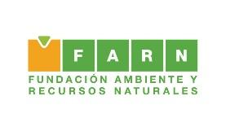
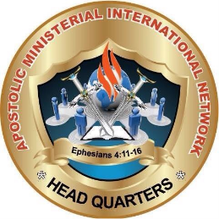

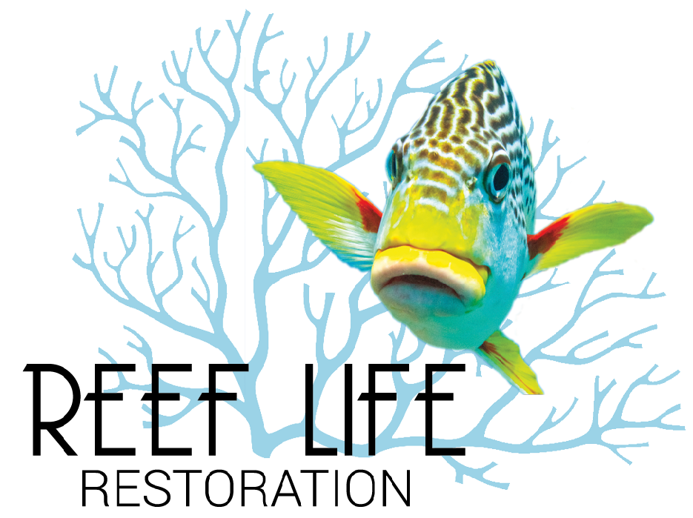
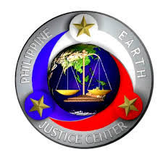
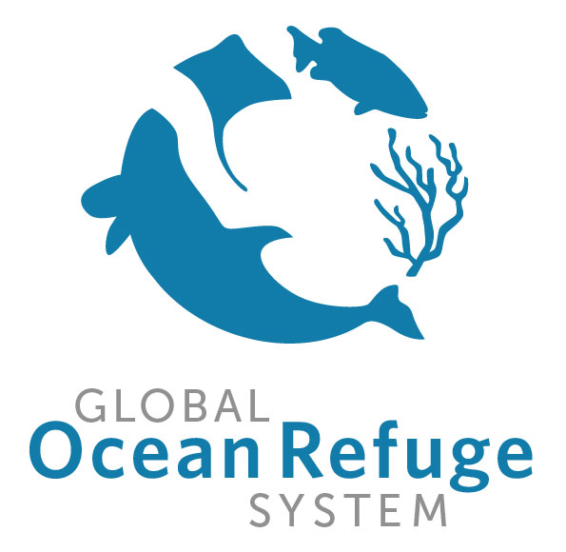
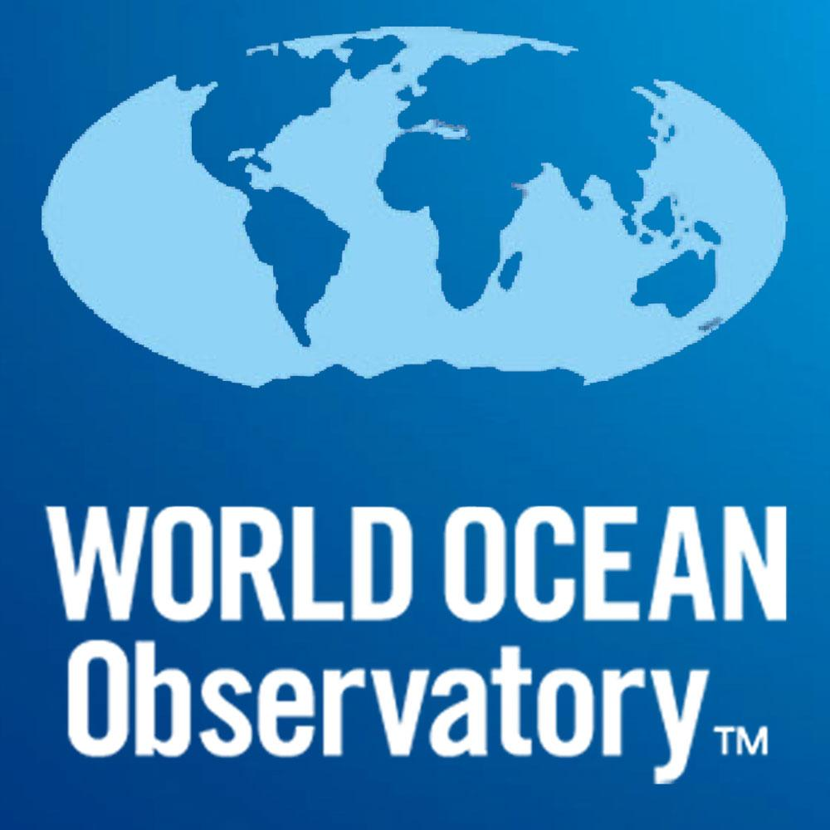
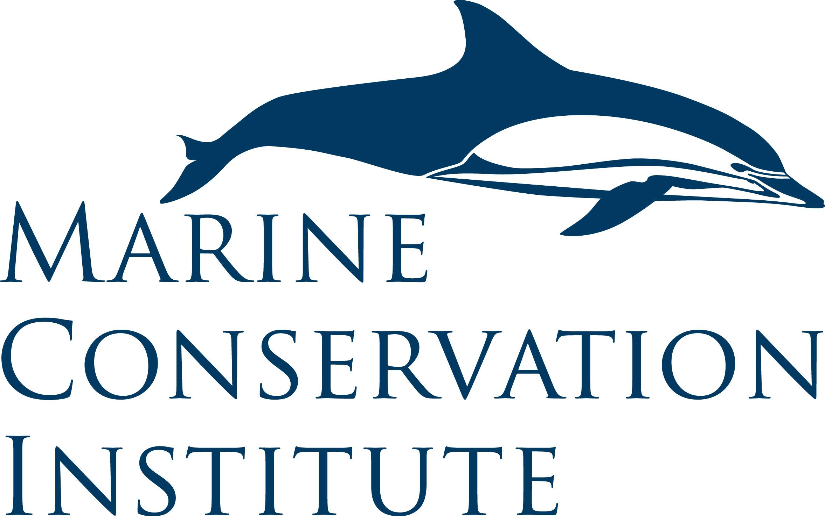
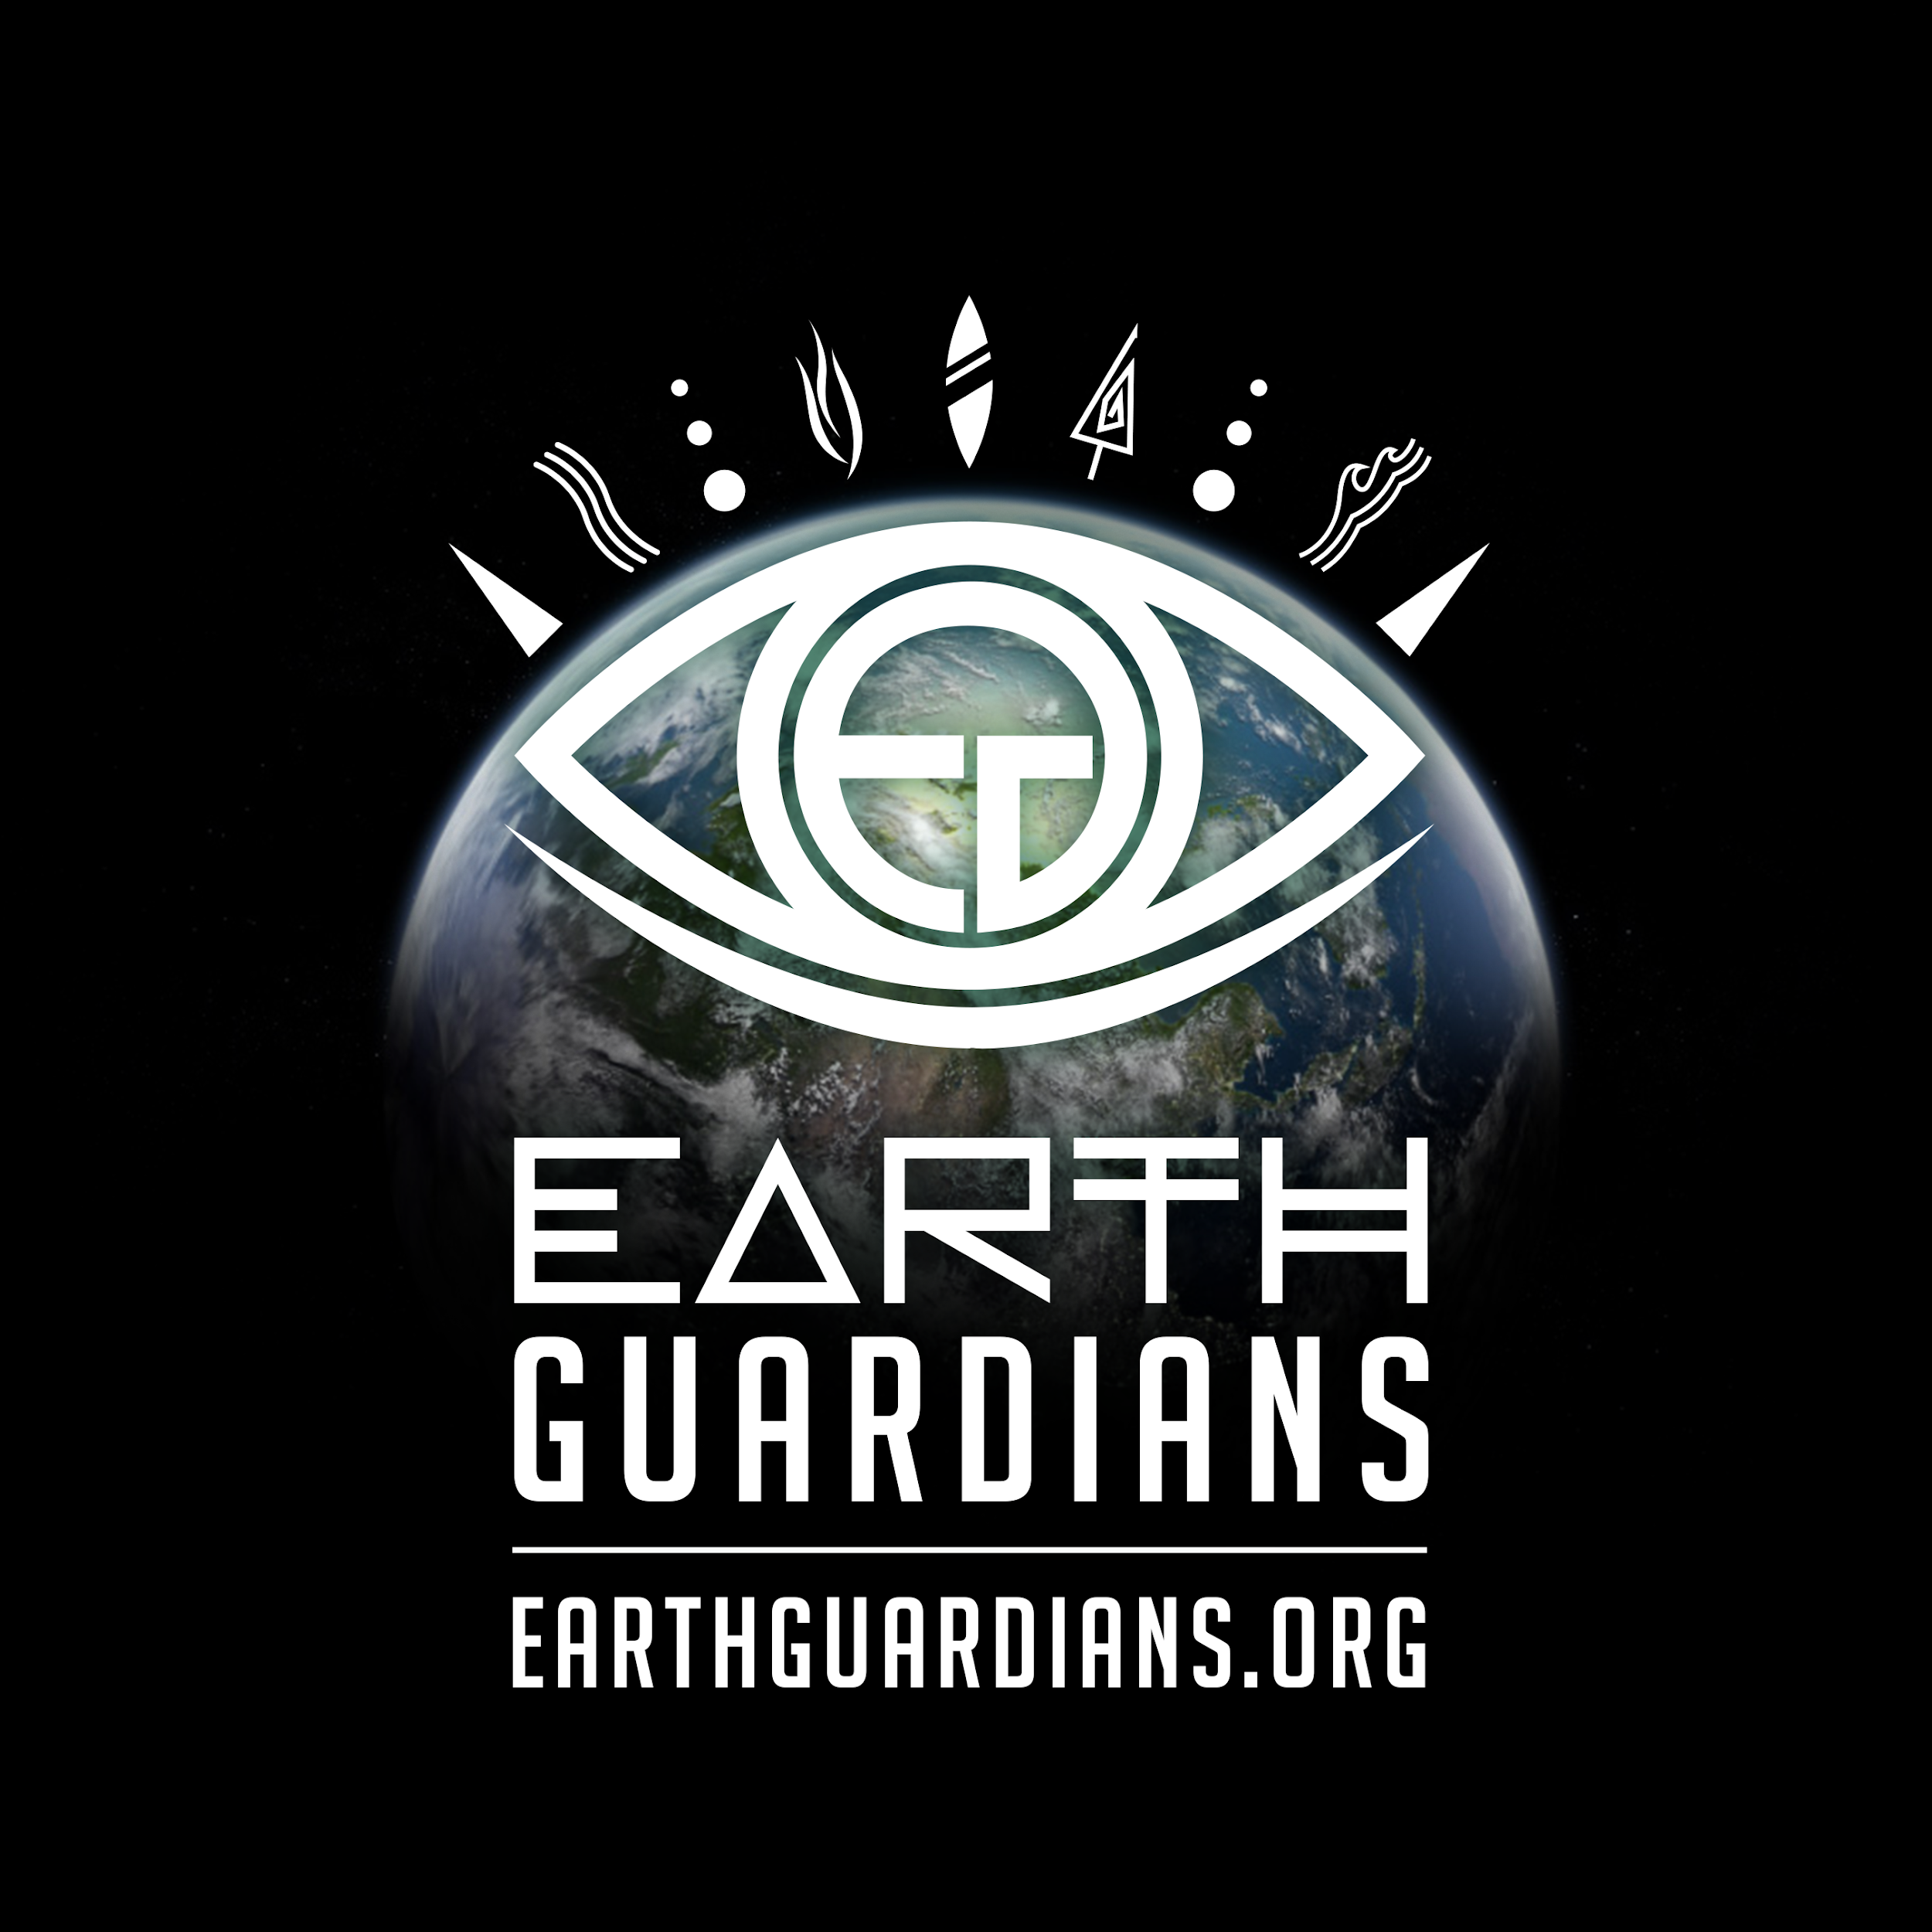
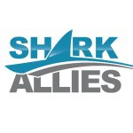

Signatories include (list still open):

Earth Law Center, USA, mbender@earthlaw.org
Advocates for Natural resources and Development, Uganda
African Development Assistance Consult (ADAC), Democratic Republic of Congo
Alternative Policies for the Southern Cone of Latin America (PACSInstitute), Brazil
Amis de l'Afrique Francophone-Bénin (AMAF-BENIN), Benin
Apostolic Ministerial International Network, Ghana
Association for the Promotion of Sustainable Development, India
Association YOUTHLEAD, Togo
Augusto Carneiro Institute, Brazil
Australian Earth Laws Alliance, Australia
BCARE - UN Partnership for SDGs, USA (International)
Brazilian Humpback Whale Institute, Brazil
Carre Geo & Environment, Cameroon
Center for Earth Jurisprudence, USA
Center for Environmental Policy and Advocacy (CEPA), Malawi
Center for Humans and Nature, USA
Centre for Peace and Development, Pakistan
Climate Change Network, Nigeria
Coherence Lab, USA
Community & Family Aid Foundation, Ghana
Council of Canadians, Canada
Derechos de la Madre Tierra-Mexico, Mexico
Divers for Sharks, Brazil
Earth Guardians, USA
Ecobirth, USA
End Ecocide, Sweden
End Ecocide on Earth, France
Forum Mudancas Climaticas e Justica Social, Brazil
Foundation for a Sustainable Future, USA
Foundation for Environmental Education, Denmark
Fundación Ambiente y Recursos Naturales (FARN), Argentina
Fundación Promar, Costa Rica
Gaia Foundation, UK
Global Alliance for the Rights of Nature, International
Global Ghost Gear Initiative, International
Global Ocean Refuge System, International
Great Whale Conservancy, USA
Health of Mother Earth Foundation (HOMEF), Nigeria
Indigenous Environmental Network, USA
Institute for Nature Conservation, Albania
Instituto de Conservacion de Ballenas, Argentina
International Legal Institute of Turin, Italy
Legal-Informational Centre for NGOs, Slovenia
Lodyn, Sweden
Marine Conservation Institute, International
Mission Blue, USA
Move to Amend, USA
Movement Rights, USA
National Association of Professional Environmentalists (NAPE), Uganda
Nature Tropicale ONG, Benin
Nature’s Rights, Scotland (International)
OceanCare, Switzerland
One World Awake, USA
Organic Seed Growers and Trade Association, USA
Organización para la Conservación de Cetáceos (OCC), Uruguay
Philippine Earth Justice Center, Philippines
Reef Life Restoration and Foundation, USA
Rights of Mother Earth, Switzerland
Rights of Nature, Sweden
Sea Star Creations Ltd, New Zealand
Shark Allies, USA
Sigaw ng Kabataan Coalition, Philippines
Service to the People and Welfare of the Nation (SPAWN), Philippines
SOS Mata Atlantica Fondation, Brazil
Tenkile Conservation Alliance, Papua New Guinea
Terram Pacis, Norway
Verdeluz, Brazil
Women’s Earth & Climate Action Network, USA
World Ocean Observatory, USA
Yes to Life No to Mining, Colombia

70 orgs.
UN Harmony with Nature Experts:
Colin D. Robertson, retired EU Lawyer/linguist, Luxembourg
Craig M. Kauffman, Assistant Professor of Political Science, University of Oregon, USA
Erin Moore, Associate Professor, Department of Agriculture and Environmental Studies, University of Oregon, USA
Valérie Cabanes, End Ecocide on Earth, France

The Earth Law Framework for Marine Protected Areas, in its draft stage, serves as a guideline for adopting a holistic and rights-based approach to marine protected area governance, available at: https://static1.squarespace.com/static/55914fd1e4b01fb0b851a814/t/5a0c8a5bc83025fe16dae4d9/1510771293987/ELC+MPA+Framework+Sept+4+%282%29.pdf.
Living Planet Index, Living Blue Planet Report, at: http://www.livingplanetindex.org/projects?main_page_project=BluePlanetReport&home_flag=1.
Division for Ocean Affairs and the Law of the Sea, “The oceans are the very foundation of human life,” Office of Legal Affairs, United Nations, 2011, at: http://www.un.org/depts/los/oceans_foundation.htm
Division for Ocean Affairs and the Law of the Sea, “Marine biological diversity beyond areas of national jurisdiction,” Oceans & Law of the Sea, United Nations, 2012, at: http://www.un.org/Depts/los/biodiversityworkinggroup/marine_biodiversity.htm
Earth Law Center, A Vision for Ocean Health in California, March 2016, at: http://bit.ly/ELCOcHeR.
California Ocean Protection Act, Pub. Res. Code § 35505(c)
IUCN Programme 2017-2020 : approved by the IUCN World Conservation Congress, September 2016, Target 15, Pg. 35, at: http://bit.ly/2kkHWCo
Available at: http://www.un.org/ga/search/view_doc.asp?symbol=A/RES/71/232
Concept Note: Interactive Dialogue of the General Assembly on Harmony with Nature in Commemoration of International Mother Earth Day; Theme: Earth Jurisprudence, UN HQ New York, April 2017, Trusteeship Council, at: http://harmonywithnatureun.org/content/documents/438HwN.ConceptNote.2017.pdf
World Charter for Nature, U.N. Doc. A/37/51 (1982), at: http://www.un.org/documents/ga/res/37/a37r007.htm.
Sustainbale Development Knowledge Platform, United Nations, avaialble at: https://sustainabledevelopment.un.org/topics/oceanandseas.
Lewis, N., Day, J.C., Wilhelm, ‘A., et. al, Large-Scale Marine Protected Areas: Guidelines for design and management. Best Practice Protected Area Guidelines Series, 2017, No. 26, Gland, Switzerland, p. 4, available at: https://portals.iucn.org/library/node/46933.
Id. at 18.
Charles W. Fowler, Andrea Belgrano, and Michele Casini, Holistic Fisheries Management: Combining Macroecology, Ecology, and Evolutionary Biology, Marine Fisheries Review (Scientific Publications Office, National Marine Fisheries Service, NOAA), 75 (1–2), 2013, p. 1, at: http://aquaticcommons.org/14550/1/mfr751-21.pdf.
Id. at 2.
Fowler, C. W., R. D. Redekopp, V. Vissar, and J. Oppenheimer, Pattern-based control rules for fisheries management. U.S. Dep. Commer., NOAA Tech. Memo. NMFS-AFSC-268, 2014, p. 2, at:https://www.afsc.noaa.gov/publications/afsc-tm/noaa-tm-afsc-268.pdf.
Rogers, A.D. & Laffoley, D.d’A. 2011. International Earth system expert workshop on ocean stresses and impacts. Summary report. IPSO Oxford, 18 pp.
Fisheries Management-2. The Ecosystem Approach to Fisheries, Food and Agriculture Organization of the United Nations, 2003, at: http://www.fao.org/3/a-y4470e.html.
Id.
Universal Declaration of the Rights of Mother Earth, 2010, available at: http://www.rightsofmotherearth.com/declaration-of-the-rights-of-mother-earth
The Earth Law Framework for Marine Protected Areas, in its draft stage, serves as a guideline for adopting a holistic and rights-based approach to marine protected area governance, available at: https://static1.squarespace.com/static/55914fd1e4b01fb0b851a814/t/5a0c8a5bc83025fe16dae4d9/1510771293987/ELC+MPA+Framework+Sept+4+%282%29.pdf.

